


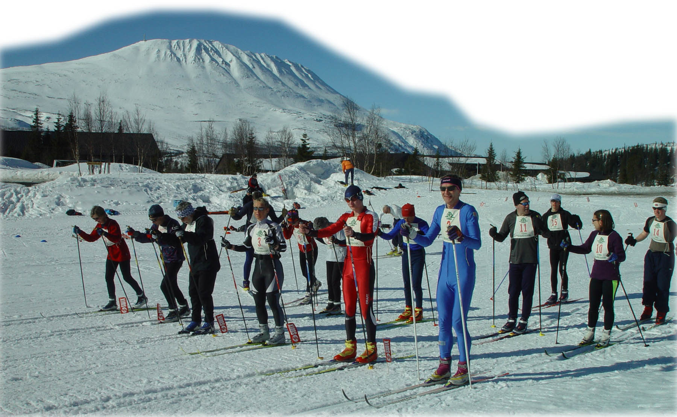

On-snow Nordic skills, coaching awards and activity week

Kvitåvatn, Norway, 1–8 April 2006
This will be the sixth year Snowsport England has held its highly successful ‘On-Snow’ course at Kvitåvatn. Based at the welcoming Fjellstoge, it attracts an enthusiastic body of cross-country and free-heel downhill skiers of all levels to share in a truly varied skiing experience. Under the leadership of Senior Coach Patrick Winterton and his talented team, this course has rapidly gained a reputation for the high quality of its coaching.

Among the coaches are:
Patrick Winterton will be planning the week’s programme. Regular viewers of cross-country skiing and biathlon on Eurosport and/or Channel 4 will know Patrick for his commentary and in depth analysis of the sport. Patrick skied with the British Nordic Team for eight years, competing on both the World Cup Circuit and at the Olympic Games in Calgary. After retiring from International competition Patrick became a Snowsport England Nordic coach, a position he has held since 1991. He is now a Snowsport England Senior Tutor.
His team will include Mike Dixon, Britain's most successful biathlete. He is the only British athlete to have competed at six Winter Olympic Games, the first in the Nordic discipline in Sarajevo in 1984 and the last five in Biathlon. Mike has also competed at thirteen World Championships, eleven of these in Biathlon and two in cross-country. Since retiring from competition, after the Olympics at Salt Lake City in 2002, Mike has become a commentator for Eurosport and Channel 4. He is a Snowsport England Nordic Coach and Tutor.
Andy Stewart is a qualified BASI Telemark Instructor and a Senior Tutor for Snowsport England in both Nordic and Alpine disciplines. He holds a Mountain Instructor Award and is a ‘provider’ for the Mountain Leader Training Board. Andy is a specialist in Outdoor Education.
Ian Johnston is a true mountain man with over 20 years experience as a mountaineer and Alpinist. He is a Snowsport England Nordic Downhill Coach and holds a Mountain Instructor Award.

Who is the course for?
- Cross-country skiers who wish to improve their skills, whether their interests are in touring, racing or free-heel downhill.
- Alpine skiers who wish to improve their downhill skills by converting to free-heel downhill/ telemark skiing.
- Members of the Snowsport England Coaching Scheme who wish to be trained and assessed for, or revalidate, an award.

What will we be doing?
Mornings will usually be devoted to skills training in groups of similar ability. The XC groups will concentrate on classic and skating techniques on local tracks. The free-heel downhill groups will practice techniques, leading up to and including telemark turns, on the piste. The afternoons will include a range of activities, such as ski orienteering, snow holing, fun races, and ski touring. There will be the opportunity to alternate between the XC and downhill groups. Assessment for Snowsport Engand Proficiency Awards will be available. Coaching personnel will be working with a Tutor/Senior Tutor.

Where is it held and where do we stay?
We stay in the hospitable Kvitåvatn Fjellstoge, 1000m above the town of Rjukan. The south-facing site, overlooking a frozen lake, is dominated by Gausta (1883m), the highest mountain in southern Norway. The well-maintained loipe offer excellent skiing over rolling terrain; the freeheel downhill groups will use the nearby downhill pistes and the area provides splendid mountain touring.
Accommodation is in 4 bed and 2 bed bunkrooms and self service meal arrangements include Norwegian style breakfast buffet (where you make your own packed lunch) and full evening meal. Tea and coffee are available all day at no extra charge for residents.

How do we get there and how much does it cost?
Coaching costs are £225 for the week.
Independent travellers: Participants may prefer to book their own flight to Oslo and make their own onward travel arrangements to Kvitåvatn (advice on flights and bus transfer can be obtained from the organiser). Accommodation and meals will be NK 2618 (approx. £240 for the week) in a three-plus bunk room or NK 3185 (approx. £292) for a 2-person room, bookable through the organiser and payable directly to Kvitåvatn Fjellstoge at the end of the week.
or
Waymark Holidays: Alternatively, a package to include flights from London Heathrow, transfer, accommodation and meals can be arranged through Waymark Holidays. The cost for this will be £499 based on a three-plus bunk room (2-bunk rooms are available at additional cost). Waymark can also offer a transfer-only package between Oslo and Kvitavatn (contact organiser for details).

Equipment?
Participants are encouraged to bring their own equipment: lightweight track skis and waxes for the XC course and heavier metal edged equipment for the freeheel downhill course. However, equipment for both XC and freeheel downhill can be hired at the centre and waxes bought from the hotel reception.

How do I book?
- Complete the booking form below and return with £80 coaching fee deposit. The remaining balance of £145 to be paid eight weeks before departure. Cheques made payable to ‘Snowsport England’.
Independently:
- Accommodation bookable through the organiser on behalf of Snowsport England.
- Book your own flight. Contact the organiser for advice on times and transfer arrangements.
Or through Waymark Holidays,
- Telephone or email to book flight, transfer, accommodation and meals, or obtain a booking form from the organiser.
Waymark Holidays, 44 Windsor Road, Slough SL1 2EJ. Tel: 01753 516477
Email: enquiries@waymarkholidays.com

This course is organised by Helen Bell on behalf of Snowsport England.
Address: 5 Kingsley Ave, Birkenshaw, Bradford, W.Yorks., BD11 2NQ
Tel: 01274 875680 Email: helen@hebell.fsnet.co.uk

