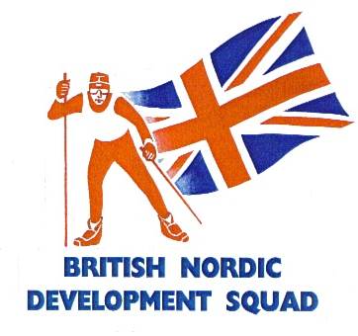 | 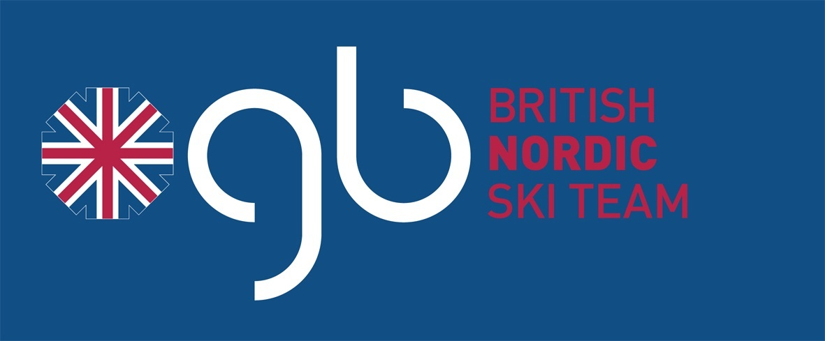

British Nordic Development Squad

The British Nordic Development Squad is an organisation catering for 11-23 year olds interested in getting into competitive cross-country ski racing. It aims to produce athletes competitive with counterparts from snow nations. The squad primarily promotes juniors aged skiers.

As well as supporting competitive cross-country skiing, the squad also exists to promote the benefits of an athletic and healthy lifestyle. Emphasis is placed upon the fun aspect of sports participation and upon the support and friendship to be found in a squad or team environment. Squad officials and coaches seek to actively foster a supporting, caring yet challenging and fun environment from which all athletes benefit. Senior athletes are given opportunities to further develop their personal and social skills through leadership and role modelling. We hope that squad athletes will become the leaders and coaches of the future.

Entry to the squad
Entry to the squad is open to any athlete over the age of 11 years who has developed a love for the sport of cross-country skiing and who additionally has been recommended by their own club coaches. Interested skiers not associated with a club are able to attend a camp to see if they can pursue the sport to the highest level.
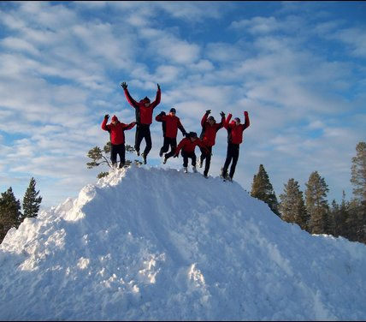
The development squad feeds athletes into the Snowsport GB Nordic teams. The Nordic teams each have a selection criteria and specific aims. Non-members of the development squad can also qualify for the teams if they make the selection criteria.
Selection criteria can be viewed on the Snowsport GB website at: www.snowsportgb.com/policies.

Squad Training Structure

The squad holds several training camps throughout the summer and winter. In summer the camps are held throughout Britain. There is generally 1 week long camp.
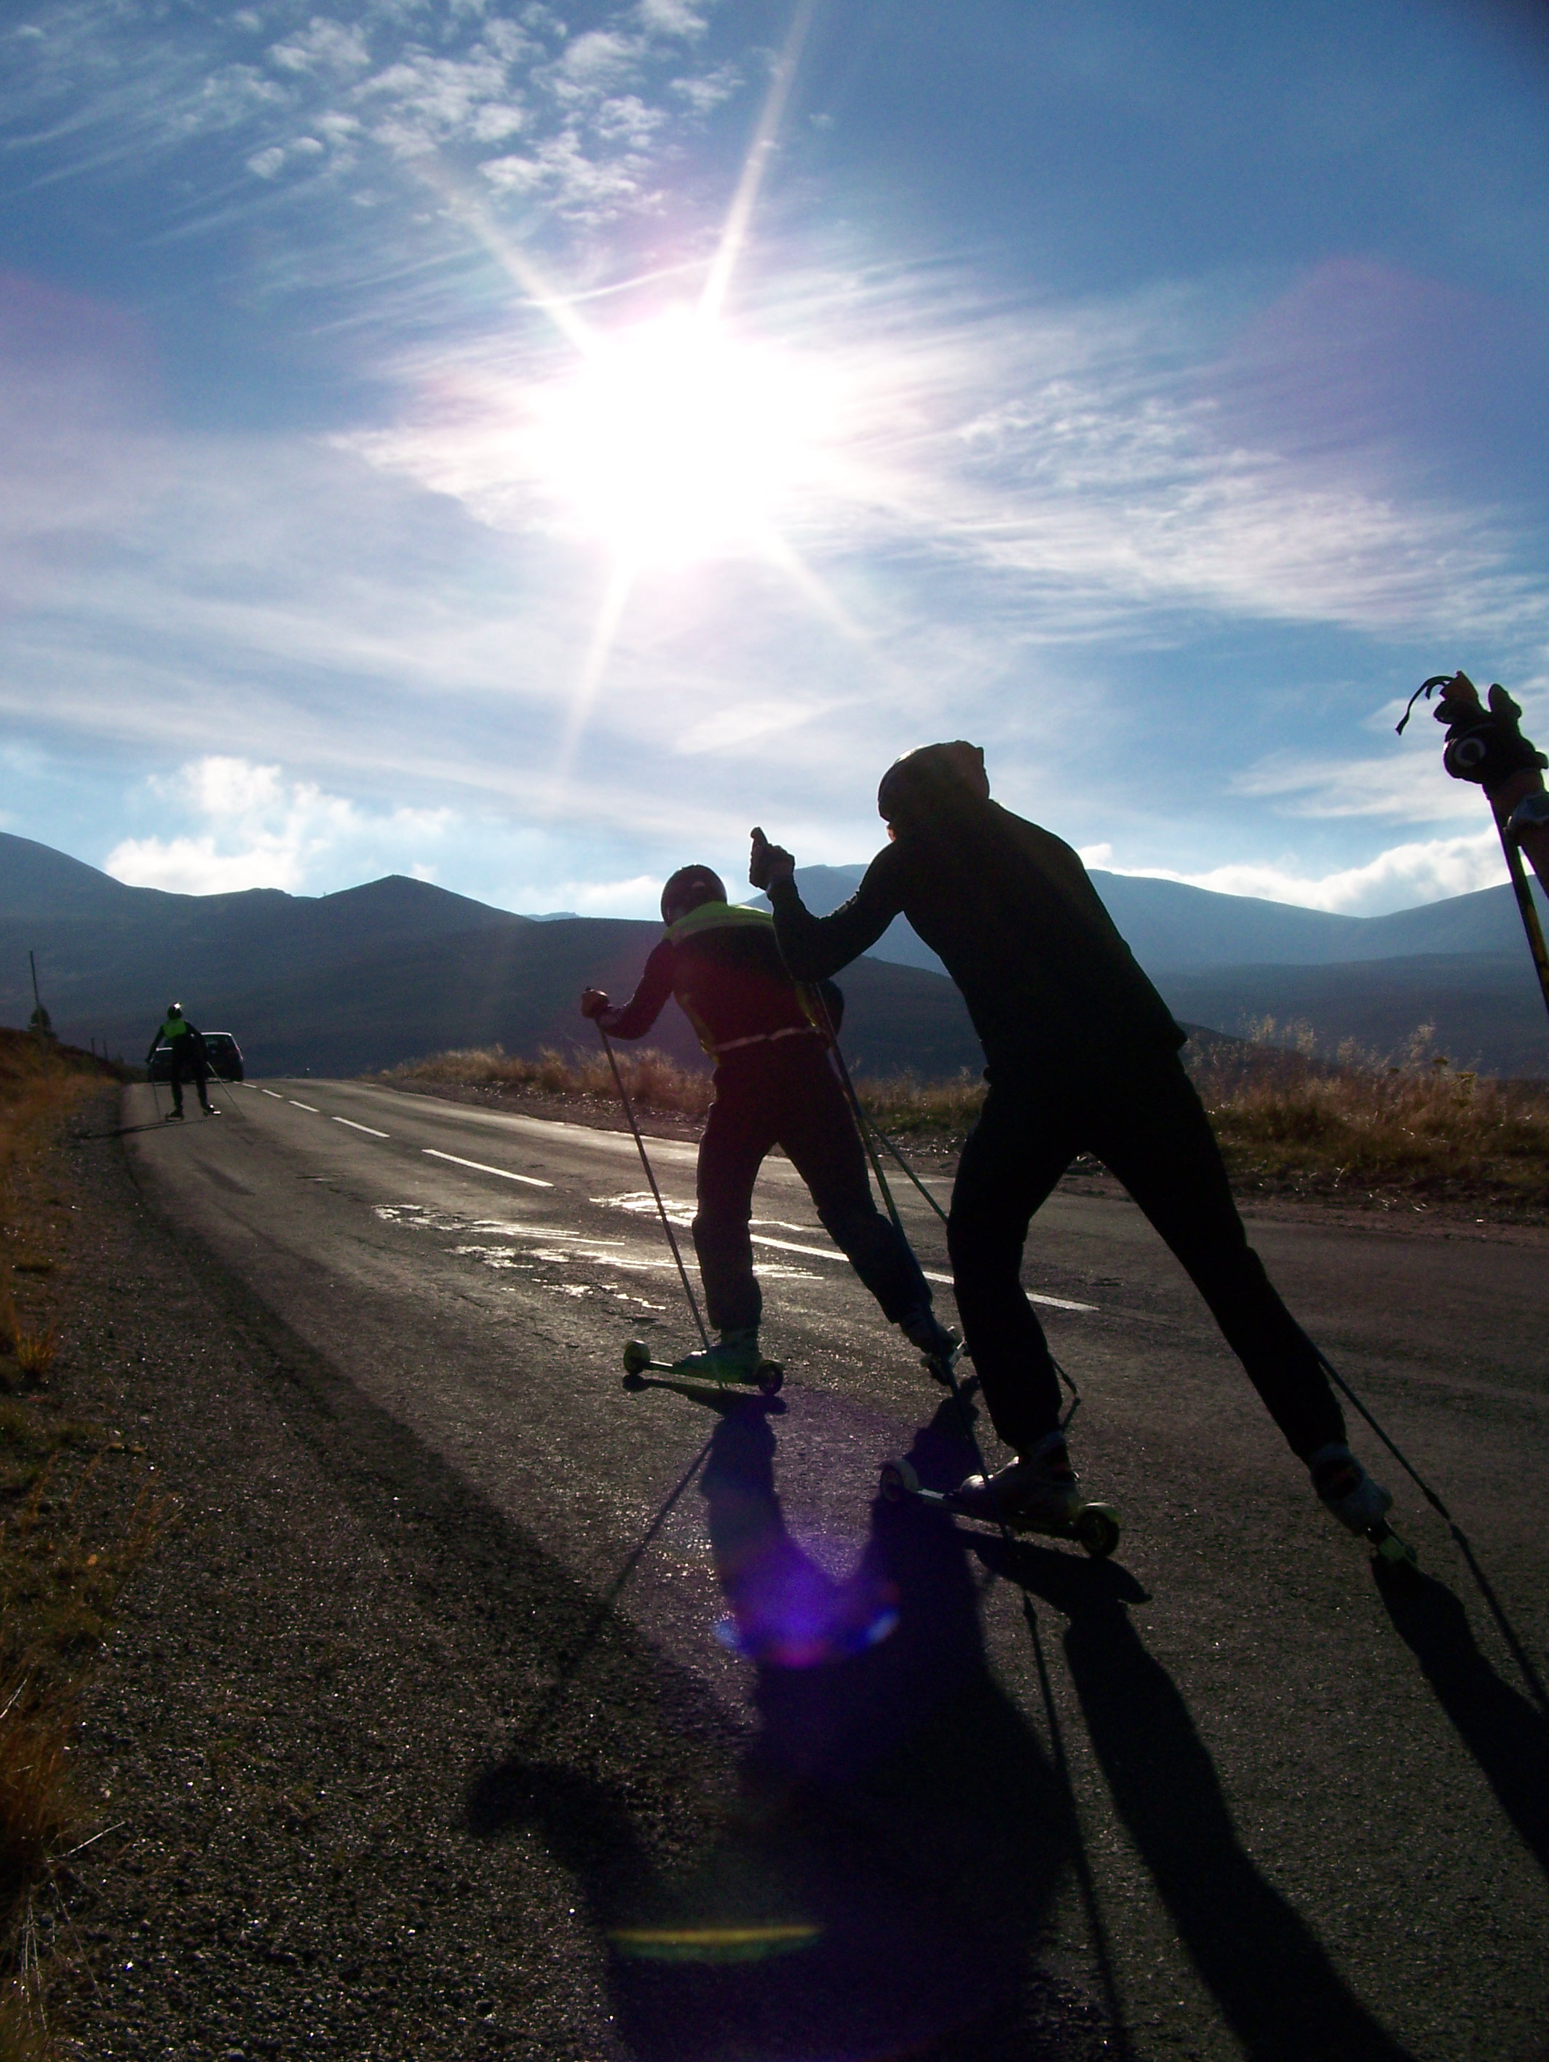
In October there is also another week camp. As well the long camps there are weekend camps spread throughout the summer targeting roller ski race weekends. At camps the athletes are coached at each session doing a variety of activities from roller skiing to running and strength. Outside camps the athletes are provided with an individualised training program from a squad coach.

In the winter there is a camp for about a week in duration over the Christmas period. For the past couple of years this has been held in Sjusjoen, Norway. This camp primarily focuses on training, and although there will be time trials, large races are not generally attended. Race camps are held at other times in the year, with the squad travelling to targeted races. The British Championships are open to all squad athletes. Coaches will advise on which other races are relevant to athletes. Other races included FIS and club races throughout Europe, in Norway, Austria and Poland, and the Austrian Junior Championships. Selection criteria for higher-level races, such as the World Junior Championships, is set by Snowsports GB.

Find Out More
The team is holding an open session before the London region Ski Club, Hayes roller ski race on 10th May. The aim will be allow interested young skiers to train with the squad and meet members of the British Nordic Ski Team. After the roller ski race there will be an opportunity for skiers, parents and other club members to meet with the team and coaches.
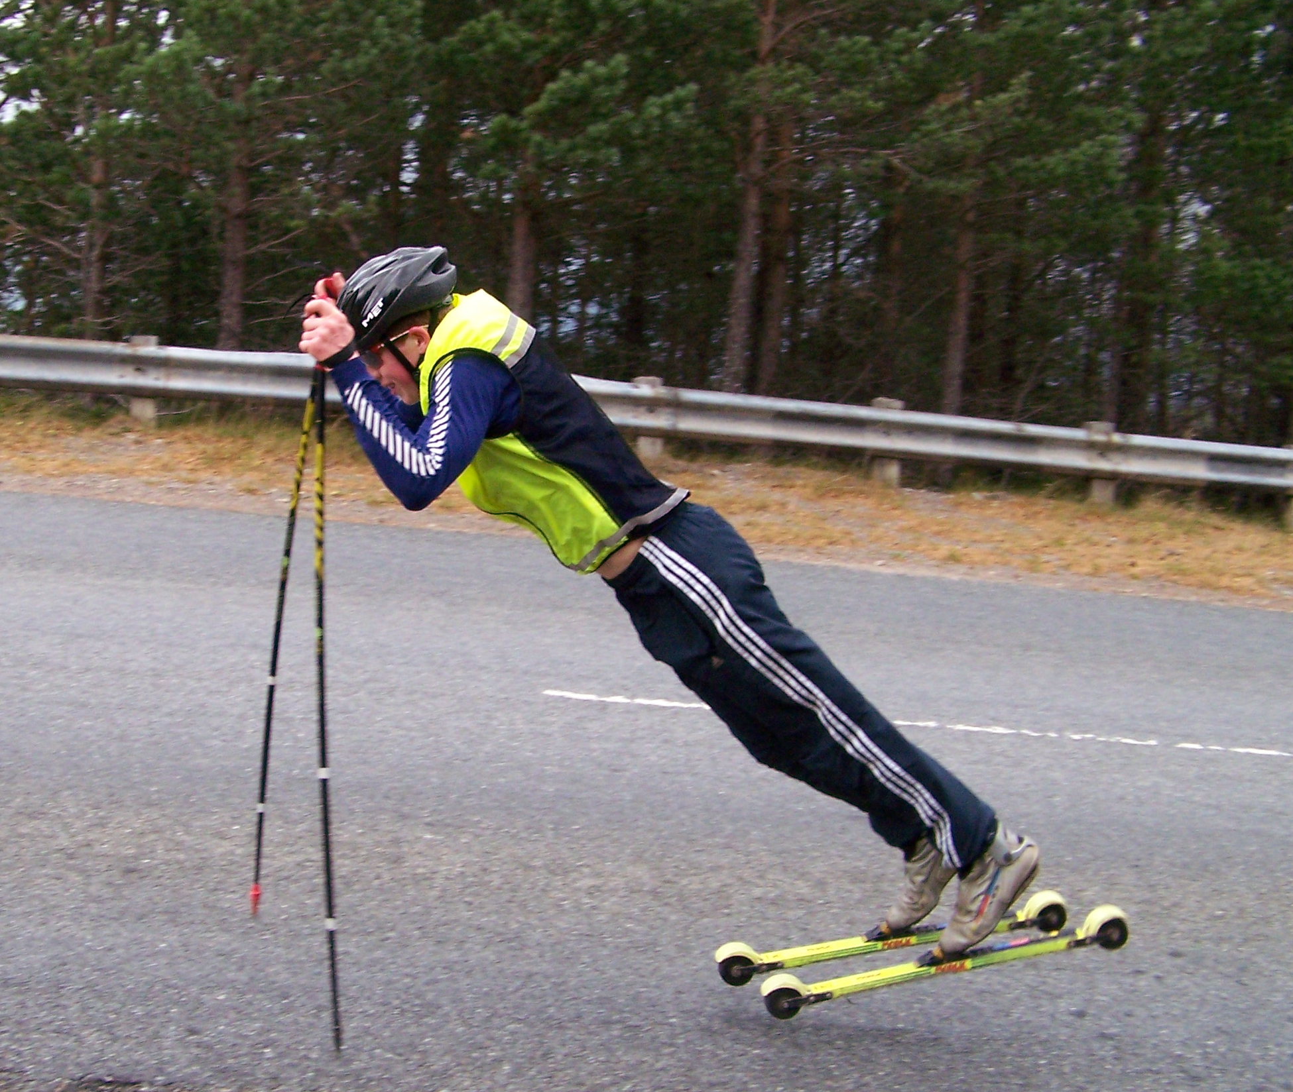
Provisional timetable:

10.30 Meet at Hayes (Hillingdon Cycle Track)
10.45 Coached session
12.00 Lunch
12.30 Coached session
2.00 Feedabck and what happens next
3.00 Roller ski race (optional)

If you want to come along but don’t have equipment please let us know so that we can supply.

British Nordic Ski Team
Athletes who have met the qualification criteria are selected for the British Nordic Ski Team, which supports the athlete’s progression in international competition. In the last few years there has been a remarkable increase in British athlete’s performances, with successful teams at both the European youth Olympics and World Juniors and for the first time in fourteen years, qualification for World Cup. Britain is in the staggering position of having the world number one in under17 and the world number nine in under19.

Who to contact:
Squad Head Coach: Roy Young
Email: tout.tele@vodafoneemail.co.uk, Phone: 01466 793347, Mobile: 07767694129

